Contents
2.2A UK Support – Detailed Delivery Plan 2
One accountable UK operating model 2
Lead-time control begins at purchase-order receipt 3
Regional coverage with national resilience 4
Service, repair and asset evidence 6
Controlled parts infrastructure 7
Engineer vehicles as mobile parts stores 8
Congleton central warehouse and urgent fulfilment 9
Direct-to-site delivery and controlled follow-on 10
Type A, obsolescence and refurbishment 11
MODService, the operational MOD portal 11
Continuity, management information and contract commitment 13

2.2A UK Support – Detailed Delivery Plan
Tender Question: Demonstrate your ability to service, repair and maintain physical training equipment at multiple locations throughout the UK. Describe the infrastructure you will have in place to support this.
Scoring Focus: A detailed UK-specific plan; process map with timescales; lead-time breakdown and evidence; relevant third parties; infrastructure capable of sustained delivery.

Pulse Fitness will deliver the UK requirement through fourteen regionally distributed engineers under the direct control of the Congleton Service & Aftersales team. The field network is supported by a substantial central warehouse, area-tailored van stock, mixed-brand technical expertise, controlled service and parts processes and MODService as the dedicated MOD fault-reporting and asset-visibility portal.
14 | 5,051 | £7.5m+ | Next day
UK engineers | stocked product codes | recorded stocked parts value | UK stocked-parts route

One accountable UK operating model
Pulse Fitness will manage the complete service journey from Congleton: purchase-order validation, job registration, customer contact, triage, engineer allocation, technical escalation, parts, service evidence, MSys.SIP status, invoicing and management information. Regional engineers provide the local response, but the customer does not have to navigate separate suppliers or chase the individual engineer for progress.

The model has been designed for a geographically dispersed and mixed-brand estate. It balances local response with technical suitability, so that the engineer attending has the right equipment knowledge and preparation rather than simply being the closest available resource. The same central team can redirect work, arrange overnight stays, coordinate another engineer or dispatch parts directly to site when conditions change.
MODService provides the operational route for authorised MOD users to report faults and view service activity. Pulse Fitness’s internal service portal manages scheduling, service records and stock, while MSys.SIP, the Supplier Information Portal, is used for the mandatory purchase-order acknowledgement and completion or delay status. This separation gives each system a clear purpose and avoids treating MSys.SIP as a day-to-day communication channel.
All UK attendance is delivered by the fourteen directly employed Pulse Fitness engineers named below. No third party service provider will attend a UK MOD site under this agreement. The third parties used on the requirement are suppliers rather than service providers: original-equipment and approved-equivalent parts suppliers, and tracked-delivery carriers including DPD.
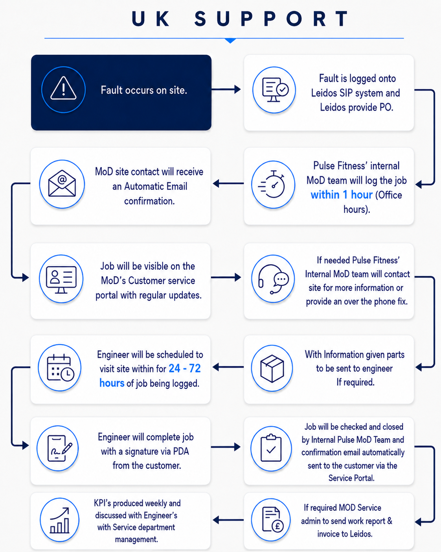
Figure 1, UK support workflow from fault notification to closure.
What the figure shows: The process follows a requirement from the initial fault and Team Leidos purchase order through job creation, acknowledgement, site contact, portal visibility, engineer allocation, attendance, customer sign-off, evidence review, invoicing where required and performance reporting.
Why it matters to the MOD: The workflow gives every stage an owner and an evidence point. It reduces the risk of unallocated faults, unclear promised dates and incomplete closure, while making the operational status visible to the MOD throughout the job.

Lead-time control begins at purchase-order receipt
Pulse Fitness will timestamp the valid order immediately on receipt and acknowledge it through MSys.SIP, the Supplier Information Portal, within two working days. The service team validates the UIN, site, service type, priority, equipment and requested date before creating the job. Where sufficient information is available, the job is registered within one service-office hour, and the site is contacted in the same working period.
Where a fault can be diagnosed remotely, Pulse Fitness will offer video diagnostics before travel, confirming the asset, the likely parts and whether the site can resolve the issue without an attendance.
Priority UK locations—ships, submarines, Regional Rehabilitation Units and Primary Care Rehabilitation Centres—will be attended within 48 hours from the contractual call-out point. Standard UK locations will be attended within 72 hours unless a planned date has been agreed with the Authority. Planned services are arranged directly with the site at a suitable time and remain visible in the service diary.
The infrastructure set out in this response is what makes these attendance windows achievable in practice, and Pulse Fitness's comparable UK delivery for Team Leidos and the MOD is evidenced in full at 2.2B.
If a risk to attendance or completion emerges, Pulse Fitness does not wait for the requested date to pass. The service team records the cause, informs the customer, agrees the recovery action and enters the mandatory completion or delay status in MSys.SIP. The supporting explanation, evidence and customer communication remain within Pulse systems, MODService, email and telephone.
Control point | Tender commitment
PO and job control | Immediate receipt timestamp; MODService registration within one service-office hour where information is complete.
Priority UK attendance | Engineer on site within 48 hours for the priority categories defined in the Statement of Requirement.
Standard UK attendance | Engineer on site within 72 hours unless an agreed planned date applies.
SIP acknowledgement | Purchase order acknowledged through MSys.SIP within two working days.
UK stocked-parts dispatch | Orders confirmed before 1:00 pm can be sent for next-working-day delivery, subject to normal carrier days and site acceptance.
Confirmation of service date (KPI 1) | Confirmed to the site within 48 hours of the request, target 95%, recorded against the purchase-order timestamp.
On-time delivery to standard (KPI 2) | Work delivered on time and to the required standard, target 100%, evidenced by completion and customer sign-off.
Monthly management information (KPI 3) | Provided to Team Leidos by the fifth day of the following month, target 100%.

Regional coverage with national resilience
The UK network is positioned to provide practical regional coverage across Scotland, Northern Ireland, Northern England, the Midlands, London, the South-East, the South-West and Wales. An engineer will normally operate within approximately three hours of their home base. Where the distance, access window or task requires more, Pulse Fitness will use overnight accommodation or planned national deployment rather than create an unsafe or unreliable same-day journey.
The map is a planning tool rather than a rigid boundary. Engineers can support neighbouring areas, and the Service & Aftersales Manager may select a more distant engineer where competence, likely parts, vessel access, site risk or existing workload makes that the better operational decision.
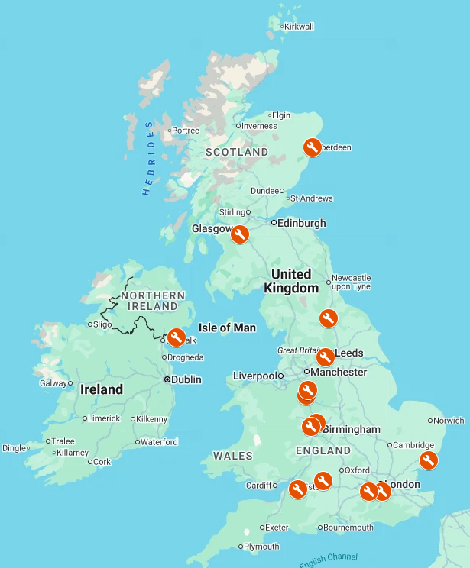
Figure 2, Current UK engineer coverage locations.
What the figure shows: The map shows the geographic spread of the fourteen current UK engineers in the same visual format as the overseas network. Locations are presented by town/base and do not disclose private residential addresses.
Why it matters to the MOD: The distribution provides local response while retaining overlapping coverage. It also shows why Pulse Fitness can use neighbouring and national resilience instead of relying on a single engineer for a large territory.
Wider engineering support from Congleton: the fourteen field engineers are supported by the wider Congleton team, including service coordination, stores and parts, technical support, design, and quality and administration. These office-based colleagues provide diagnostics, parts identification, documentation and escalation behind every visit, and their skills are integral to safe, first-time UK delivery.

Base | Named engineer | Primary operating position
Aberdeen | Aidan Greig | North-East Scotland
East Kilbride | Craig Fisher | Central and West Scotland
Kilkeel | Alan Herron | Northern Ireland
Catterick | Jim Harper | North-East England
Cleckheaton | James Ignaciuk | Yorkshire and North
Talke | Lee Blakeman | North-West and Midlands
Walsall | Ryan Somers | West Midlands
Dudley | Lee Somers (Service & Aftersales Manager) | Technical escalation and national support
Keynsham | William Ollis | Bristol and South-West
Swindon | Dave Mathias | South and South-West
Hatfield | Billy Dean | London and East
Harwich | Marcus Turner | East and South-East
Weybridge | Kieran Pearce | South-East and London
Croydon | Conrad Williams | London and South-East

Service, repair and asset evidence
Every visit must produce a clear outcome at the individual asset. Planned servicing includes visual inspection, internal and external cleaning, calibration, adjustment, lubrication, functional testing and condition reporting. Reactive work includes fault finding, safe repair where possible, parts identification and an unambiguous equipment status. Unsafe equipment is isolated or clearly status-controlled until a repair or BER decision is completed.
The engineer issues the required service certificate, obtains customer countersignature and applies the red service label. The Pulse Fitness service team reviews the evidence before closure, including the asset serial, work completed, parts, condition and next action. This central check is important because attendance alone does not demonstrate that the requirement has been completed properly.

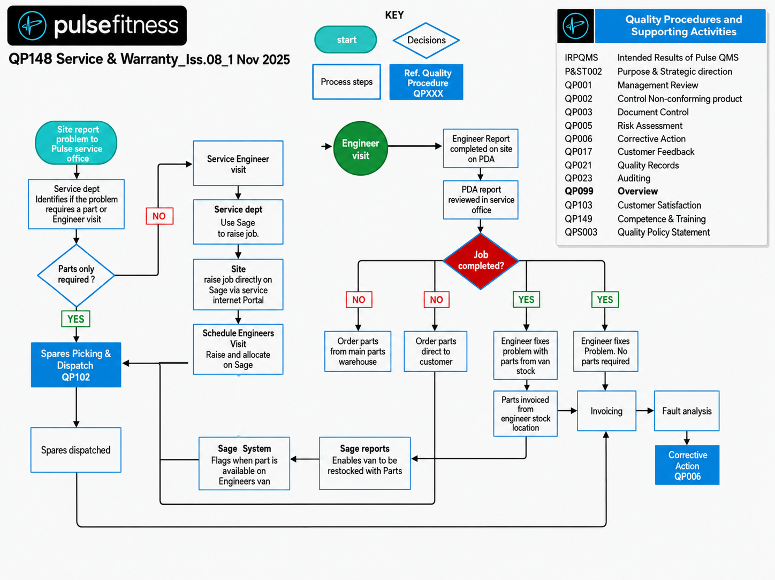
Figure 3, QP148 Service & Warranty, Issue 08, 1 November 2025.
What the figure shows: QP148 sets out the controlled route for service and warranty work, including job receipt, engineer scheduling, parts support, site activity, service evidence, further action and closure.
Why it matters to the MOD: The procedure provides a consistent standard across planned service, reactive repair and warranty work. It ensures that the customer receives a documented result and that incomplete or parts-dependent activity remains visible rather than being closed prematurely.
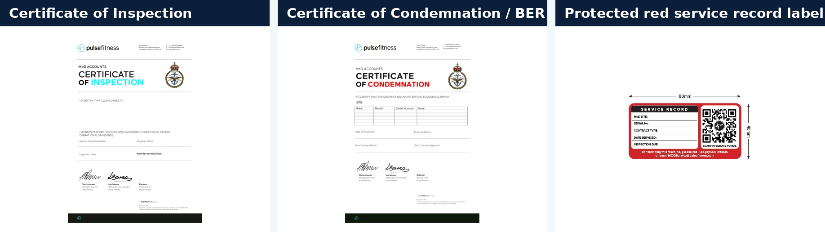
Figure 4, Formal asset-level service outputs.
What the figure shows: The figure shows the Certificate of Inspection, Certificate of Condemnation/BER and the protected red service record label used at the equipment.
Why it matters to the MOD: These outputs give the site an immediate physical and documentary record of the asset’s status. They support local safety control, audit, contract review and evidence-based replacement decisions.

Controlled parts infrastructure
Pulse Fitness combines three levels of parts support: the engineer’s area-tailored van stock, the central Congleton warehouse and external OEM or approved-equivalent sourcing. Product code, quantity, supplier and job allocation are controlled so that the correct component can be traced from stock issue through to the individual asset.
Van stock is not identical across the fleet. Each engineer carries the manufacturers and component types most relevant to the equipment population and historic demand in their area. This is a stronger approach than giving every vehicle the same list, because it puts practical stock where it is most likely to prevent downtime.
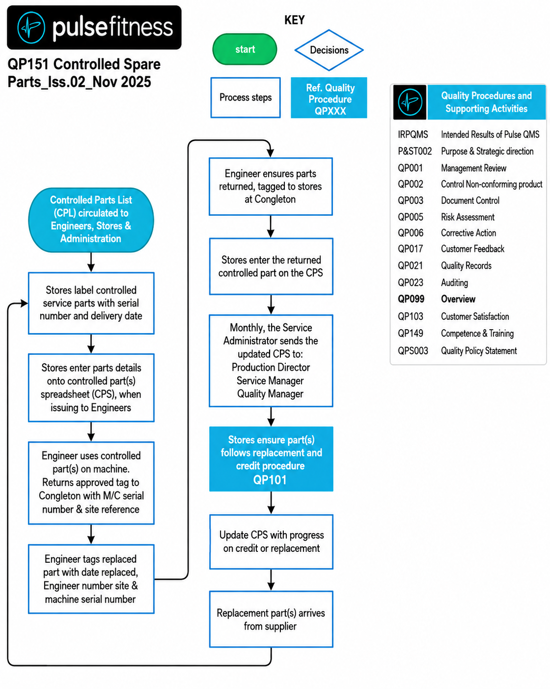
Figure 5, QP151 Controlled Spare Parts, Issue 02, November 2025.
What the figure shows: QP151 shows how parts are requested, selected, issued, replenished, returned and escalated. It includes controlled-source and traceability steps rather than treating stock as an informal engineer-held resource.
Why it matters to the MOD: The procedure reduces wrong-part events, improves traceability and allows recurring failures or supplier issues to be identified. It also supports rapid replenishment of engineer vehicles from the central warehouse.

Engineer vehicles as mobile parts stores
Ryan Somers’ van is used as a representative example of the regional stock model. It carries 665 different component lines and 1,009 physical units. More than half of those different lines support third-party equipment, including Keiser, Concept2, Wattbike and the collective Technogym, Matrix and Life Fitness category. The stock includes bearings, cables, pulleys, pedals, straps, console and electronic components, fixings and treadmill belts.
The photographs demonstrate the practical organisation behind the figures: labelled shelving, separated mechanical and electronic categories, accessible larger items and a clear working floor. The intention is to help the engineer resolve common faults during the initial attendance rather than using the vehicle as general storage.
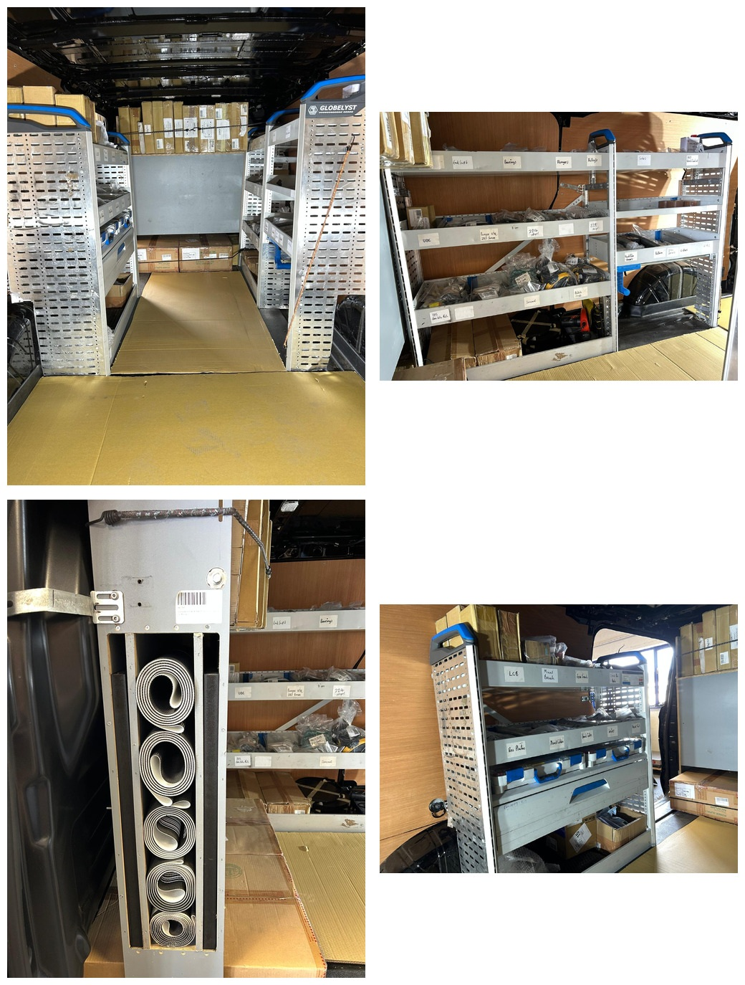
Figure 6, Representative engineer vehicle stock and organisation.
What the figure shows: The photographs show purpose-built shelving, labelled categories, electronic and console storage and larger components such as treadmill belts. Ryan Somers’ vehicle is presented as a live example; other vans are tailored to their own regional equipment population.
Why it matters to the MOD: The mobile-stock model improves first-visit resolution and reduces the time between diagnosis and repair. It also demonstrates that Pulse Fitness supports the mixed-brand estate with practical parts, not solely Pulse-manufactured components.

Congleton central warehouse and urgent fulfilment
The central warehouse records 5,051 positive-stock product codes and approximately 385,800 stock units across fourteen product groups and 106 manufacturers or suppliers. Using system sales price multiplied by positive warehouse quantity, the stockholding has a recorded commercial sales-price value exceeding £7.5 million.
The breadth matters as much as the value. The stock includes cardiovascular, strength, console, electrical, mechanical, upholstery, treadmill, studio-cycle and third-party components. More than 1,000 positive-stock product codes are categorised as Non-Pulse Parts. This gives Pulse Fitness the capability to replenish vans, support planned work and dispatch urgent diagnosed parts directly to the engineer or MOD site.
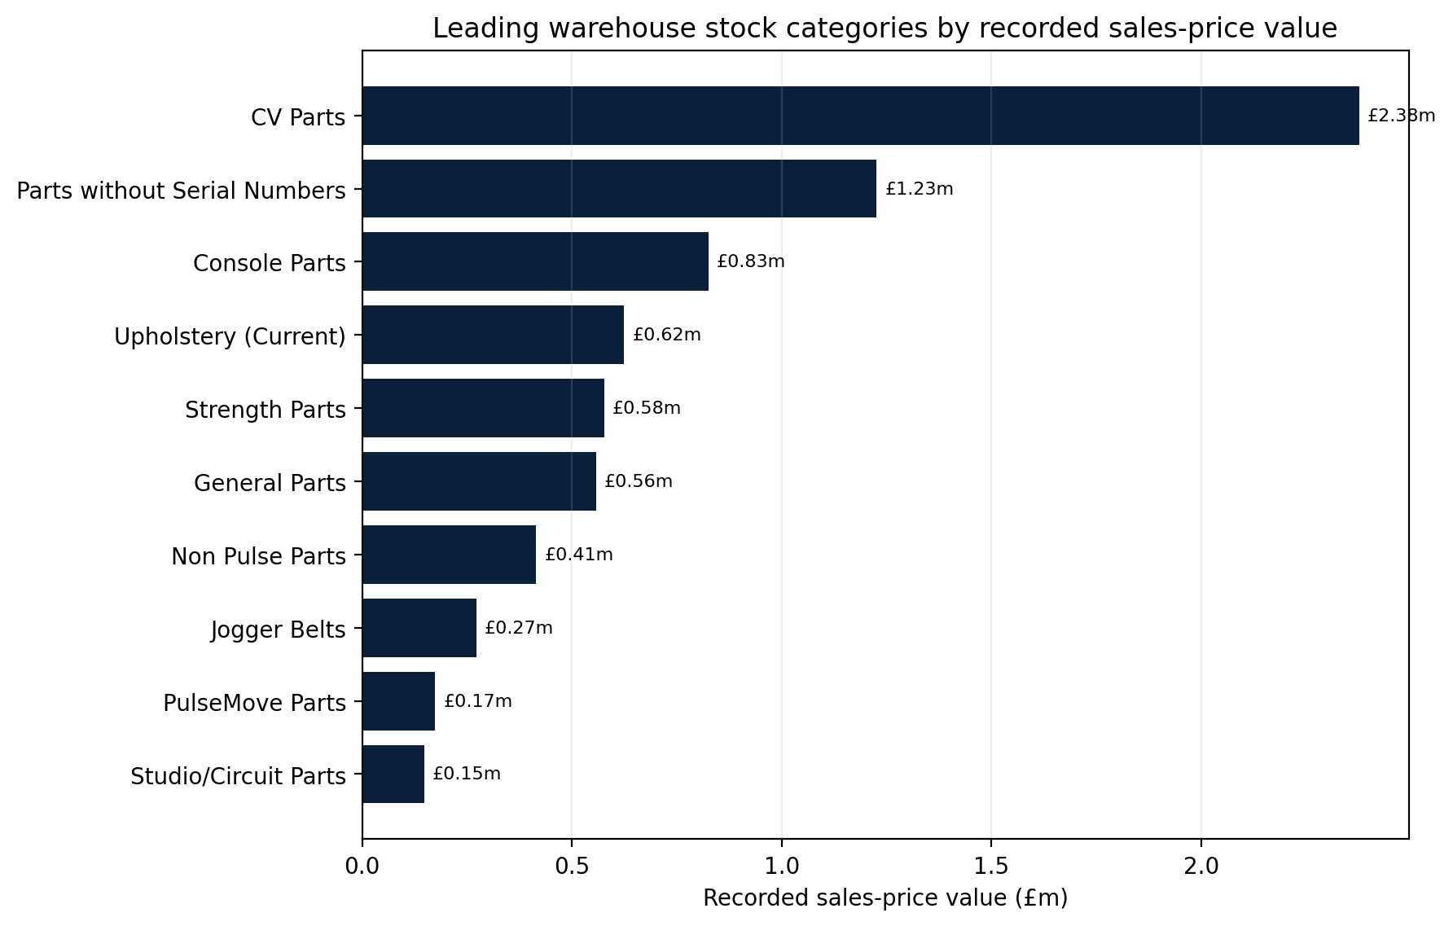
Figure 7, Leading warehouse stock categories by recorded sales-price value.
What the figure shows: The chart shows the spread of central stock across cardiovascular, console, strength, general, upholstery, treadmill and non-Pulse categories. The underlying export is retained by Pulse Fitness; the submission uses headline and representative evidence.
Why it matters to the MOD: The mix reduces dependency on a narrow range of high-value parts. It demonstrates the depth needed to support both common wear items and major mechanical or electronic repairs across a mixed-brand estate.

Direct-to-site delivery and controlled follow-on
Where a required part is not on the attending engineer’s vehicle but is available at Congleton, the supply stage can start immediately. UK orders confirmed before the 1:00 pm cut-off can be sent through DPD or FedEx for next-working-day delivery across the UK, subject to normal carrier operating days and the receiving site being available. International consignments use FedEx or DHL with a typical carrier period of three to ten working days, subject to customs and destination conditions.
All consignments are tracked by the service team and aligned with the next site action. This means a return visit is scheduled against real delivery information rather than an estimated parts date. The job remains open and visible until Pulse Fitness has reviewed the completion evidence.
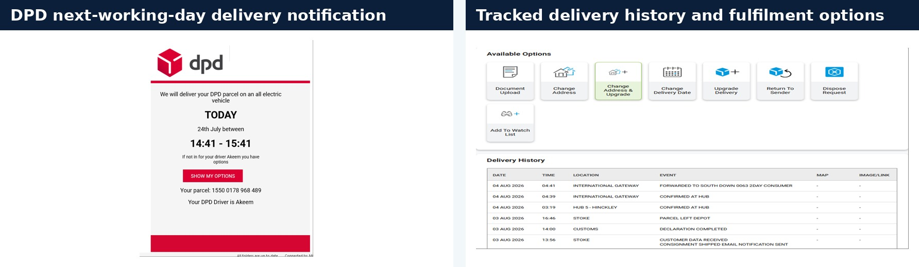
Figure 8, Representative tracked parts fulfilment.
What the figure shows: The figure combines a DPD next-working-day delivery notification with a tracked delivery-history screen showing the available fulfilment and delivery-management controls.
Why it matters to the MOD: Tracked direct-to-site delivery reduces avoidable downtime and gives the service team evidence to coordinate the follow-on repair. It also supports clear communication when international customs or local receiving conditions affect the delivery programme.

Type A, obsolescence and refurbishment
Type A will be delivered as the fixed-price, fully inclusive twelve-month service, repair and maintenance provision described in the Statement of Requirement. Once an asset has been inspected and accepted onto cover, the price includes planned servicing, annual inspection, certification, reactive diagnosis, labour, callouts, repeat attendance and the replacement components required to restore the equipment to safe working order. The only exclusions are misuse, upholstery and cycle foot straps.
Pulse Fitness will equally meet the Type B service requirements, delivering individually quoted repair, refurbishment and ad-hoc works to the same controlled standard, certification and warranty regime as Type A, priced transparently against each purchase order.
Pulse Fitness protects both parties through the pre-acceptance condition assessment rather than by introducing unlisted exclusions. Equipment already in poor condition may be declined from Type A and offered a Type B repair, refurbishment or BER route. Where a component is obsolete, Pulse Fitness will try the OEM, an approved supersession, a technically suitable equivalent or an authorised repair. If no safe and viable route exists, a BER certificate and technical explanation will be provided.
Approved refurbishment will be completed within one month of the valid purchase order as required, and Pulse Fitness will programme to four weeks. Pulse Fitness will coordinate collection, inspection, refurbishment, quality assurance and return delivery. Where mitigating circumstances extend completion, temporary equipment to the same specification will be provided in accordance with the requirement. Refurbished equipment will receive a 24-month warranty covering the agreed work, replaced components and Pulse Fitness workmanship, subject to the contract’s negligence and misuse provisions.

MODService, the operational MOD portal
MODService will be provided as the dedicated operational portal through which authorised MOD users can report faults and follow service activity. It is not an optional UK-only add-on. It creates one asset-led reporting route across the estate and gives Pulse Fitness the information required to triage accurately, prepare the engineer and retain a clear audit trail from report to closure.
Authorised users receive individual role-controlled accounts. The dashboard shows open faults, equipment status, recent activity and issues requiring attention. This provides immediate visibility without relying on fragmented email chains or local spreadsheets. The site can see the operational record, while Pulse Fitness retains central responsibility for scheduling, parts, communication and evidence.
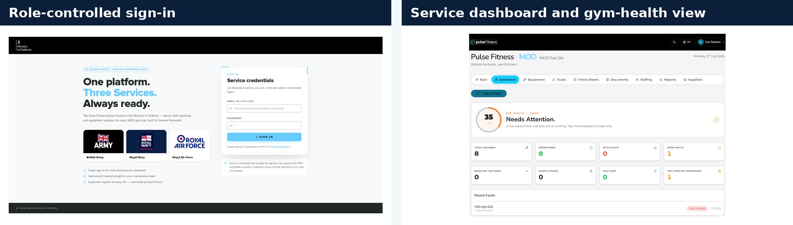
Figure 9, MODService role-controlled sign-in and service dashboard.
What the figure shows: The screens show the controlled user entry point and a live operational dashboard summarising asset condition, open faults, recent activity and items requiring attention.
Why it matters to the MOD: The MOD receives a dedicated and consistent fault-reporting route. Contract and site managers can understand the position quickly, while access remains controlled by user role.
The searchable equipment register ties every fault and maintenance action to the exact manufacturer, model and serial number. Warranty, supplier, contract, documents, service history and current status remain with the asset. QR access allows personnel on the gym floor to scan the machine, complete a check or report a fault without guessing which item is involved.
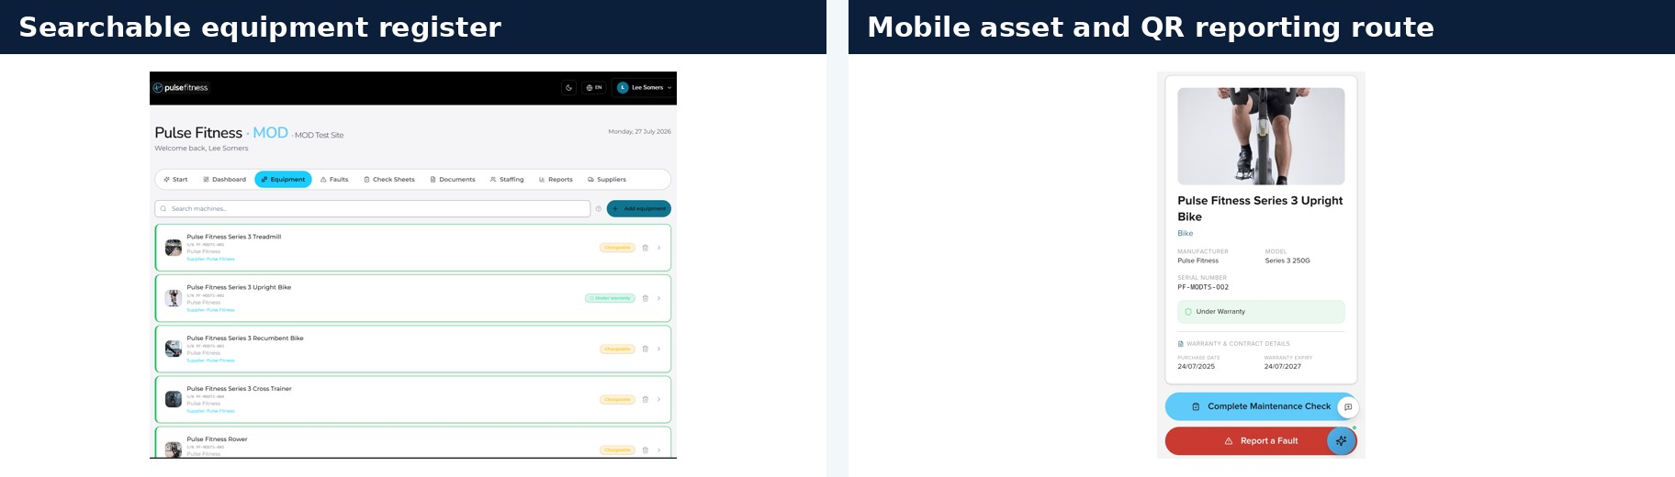
Figure 10, Searchable equipment registers and mobile QR route.
What the figure shows: The register provides the status and service history of each asset, while the mobile view allows the user to identify the machine and begin a maintenance check or fault report directly from the equipment.
Why it matters to the MOD: Correct asset identity improves parts selection and engineer preparation. It also prevents separate local spreadsheets from becoming the unofficial record of the estate.
The job card retains the site, asset, photographs, fault description, warranty, supplier reference, communication trail and status. Risk assessment support records probability, severity, residual risk and the assessor’s final judgement. Pulse Fitness uses these fields to prepare the engineer and keep parts-dependent or safety-related actions visible until closure.
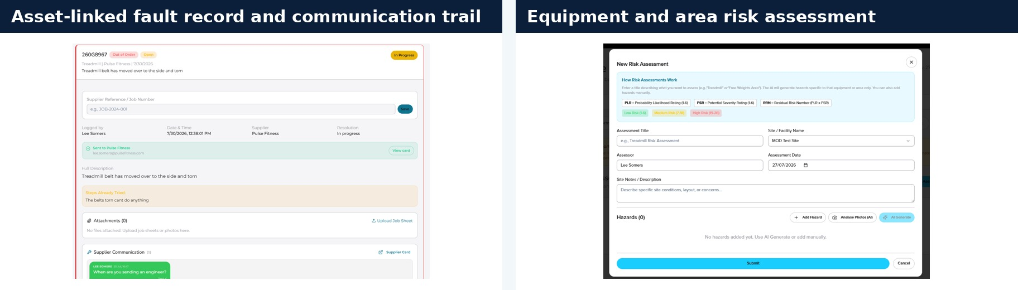
Figure 11, Asset-linked job record and risk-assessment workflow.
What the figure shows: The job record brings the fault, evidence, supplier communication and status together. The risk screen supports equipment- and area-specific assessment while retaining assessor control.
Why it matters to the MOD: The structured information improves triage and creates an auditable decision trail. It is particularly valuable where equipment must be isolated, escalated or considered for BER.
Over time, MODService turns service activity into a lifecycle evidence base. Condition, repeat faults, safety events, downtime, spend and BER status can be reviewed across a site or the wider estate. Equipment-only safety events are linked to the exact asset through the Activity Safety Events Register, while personal incidents are captured through a separate route so that injury reporting is not mixed with ordinary equipment faults.
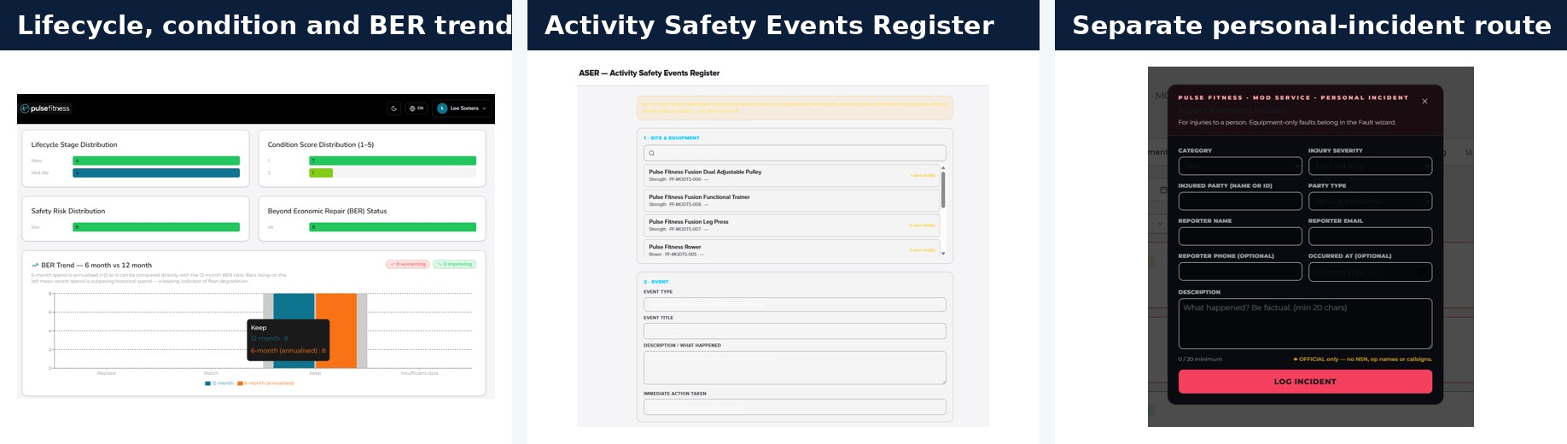
Figure 12, Lifecycle, BER, equipment-safety and personal-incident reporting.
What the figure shows: The screens show lifecycle and condition trends, an asset-linked Activity Safety Events Register and a separate personal-incident pathway.
Why it matters to the MOD: The MOD can use real service evidence to prioritise repair, refurbishment and replacement. The separation of equipment events and personal incidents improves clarity while keeping both visible to authorised managers.

Continuity, management information and contract commitment
The UK model has defined alternatives for engineer absence, vehicle failure, urgent stock requirements, system interruption and third-party parts delay. Neighbouring or national engineers can be deployed; parts can be sent directly to site; telephone and email remain available if the portal is temporarily unavailable; and safety-critical equipment is isolated and escalated immediately.

Monthly management information will be delivered to Team Leidos by the fifth day of the following month and will show demand, attendance, completion, repeat visits, open parts, planned service, customer feedback and lifecycle trends. The purpose is to allow Team Leidos and Pulse Fitness to see both contract performance and the equipment issues driving it. Recovery actions will be agreed and tracked where performance is below the required level.
Continuity risk | Planned response
Engineer absence or surge | Neighbouring engineer, national deployment, overnight stay or authorised additional support.
Vehicle or stock issue | Alternative engineer/vehicle, direct-to-site dispatch and urgent warehouse replenishment.
Third-party parts delay | Alternative source or supersession review, visible exception, recovery plan and scheduled follow-on.
Incomplete asset data | Mobilisation validation, serial check, condition grade and controlled register correction.
System interruption | Telephone/email reporting and internal service-portal continuity; MODService records reconciled when restored.
Safety-critical fault | Immediate isolation/status control, escalation and evidence-led repair or BER route.

WHY PULSE FITNESS: The UK service is not built around one promise or one system. It combines named regional engineers, central accountability, significant mixed-brand stock, controlled service and parts processes, direct-to-site fulfilment, a fully inclusive Type A route and one operational MOD portal. These capabilities are already proven on the MOD estate and are ready to scale for LSL/DC/0223.

Pulse Fitness offers a detailed and sustainable UK delivery model that makes the service easy to access, gives each asset a clear status and keeps the Authority informed from first report to final evidence. The result is lower operational risk, reduced downtime and one accountable partner for the complete service journey.

